Creating an Owner Dashboard
Owner Report- Basic

Purpose: To inform our owners about their unit performance; it focuses on providing fundamental insights without diving into more complex or granular details.
Tip: For this dashboard we are going to add three different sections

- Let’s Begin…
- On the main Menu, Click “Dashboard”

- Go to My Dashboards and click on the “Create New” button

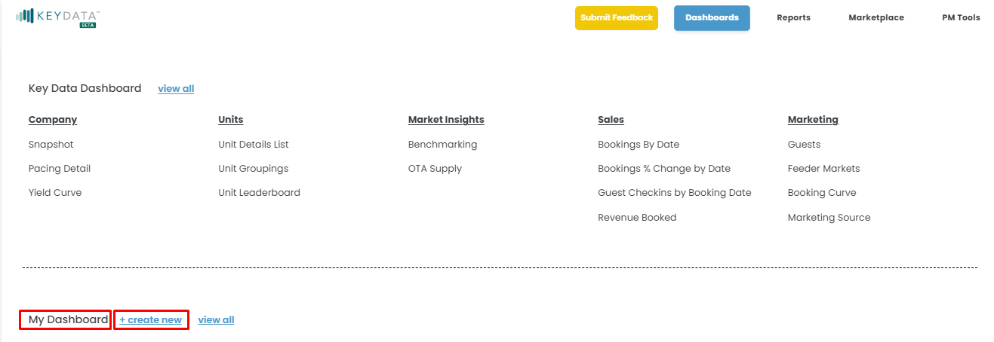

- Name your Dashboard, your first section and select your Anchor Date (Hint: for the 1st and 2nd section will be using the Arrival Anchor Date)
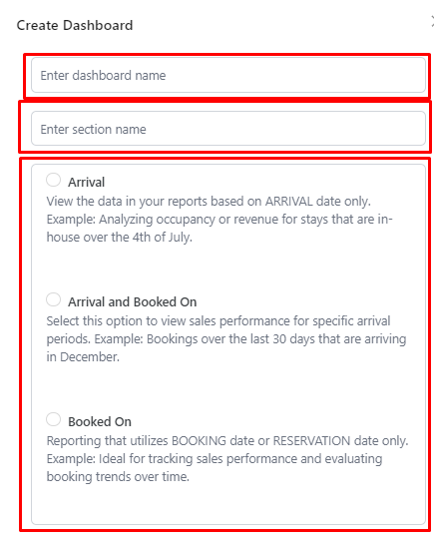
Anchor Date: Booked On for 3rd Section
Anchor Date: Arrival for 1st and 2nd Sections
Dashboard Name: Owner Report - Basic
Section Name: Unit Performance
- After creating the First Section title “Unit Performance”, a report catalog will appear. (Remember: The first section is a straightforward snapshot of how a unit is performing over time)
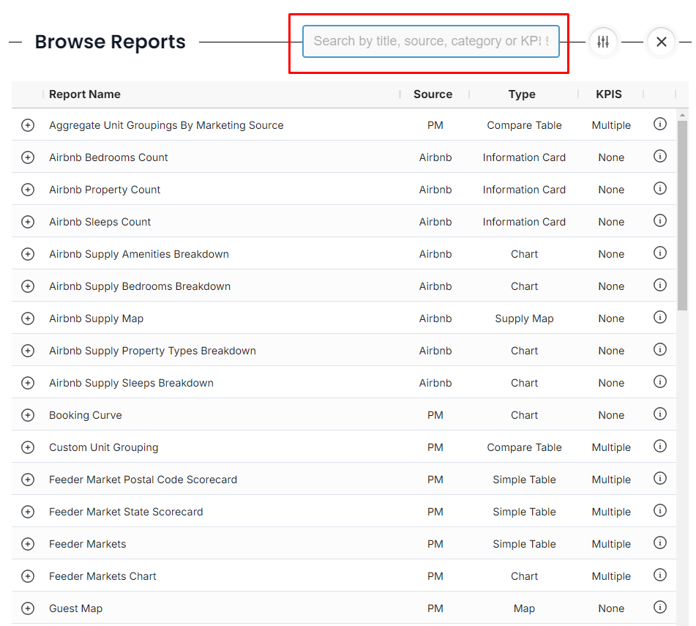

- From this catalog, browse and add the following reports to add:
- PM Scorecards
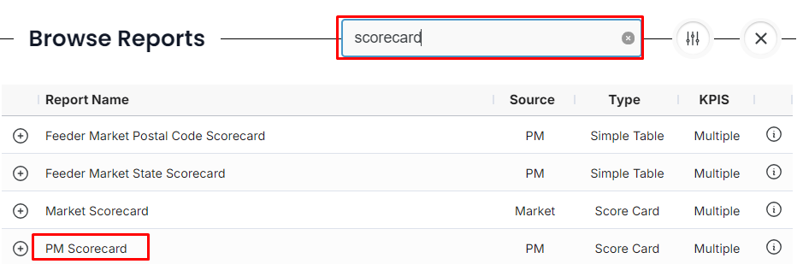

- Pacing Detail
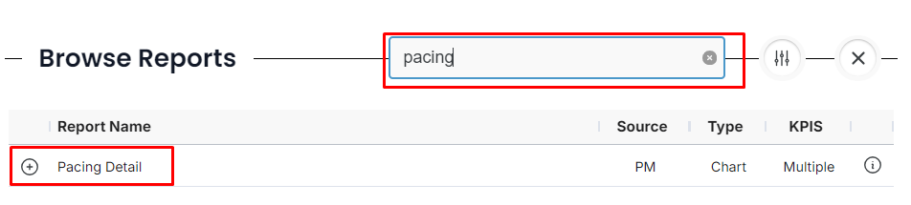
- Once you've added your preferred reports to this section, here are a few options you can explore, depending on the data you'd like to showcase:

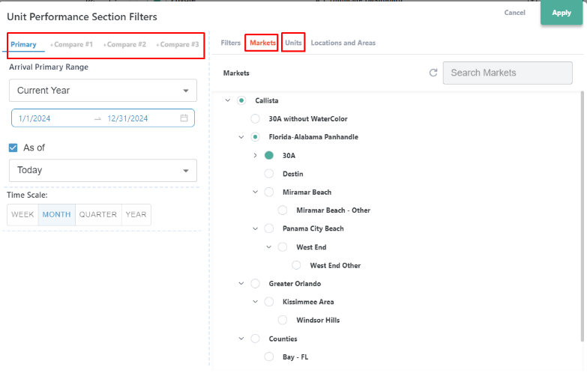
- Adjust your filters by clicking on the date filters:
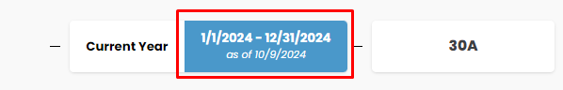

- When your filters expand you can do the following:
  - Select your primary date and comparison dates
  - Choose the market the unit belongs to
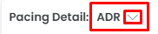
  - Select your preferred unit
  - Select preferred KPI at report level
(Suggestions: UNIT Revenue, Adj. RevPAR, APO,
ADR, Guest, Owner & Hold Nights
  - Rename, Duplicate and Delete Reports
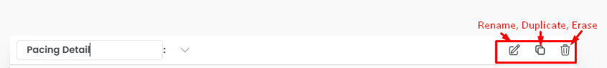
- Next, let’s create your second section, titled "Me vs. Market." (Remember: The second section is a market - high-level comparison involves benchmarking the unit's performance against the broader market)

- We have two options

  - Duplicate your section to retain the same filters as the first section:

    - After Duplicating your section, delete all reports
    - Rename the section
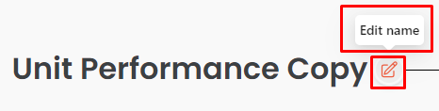
    - Add Reports

    - Add the following reports
      - Market + PM Benchmarking

    - Select preferred KPI at report level (Suggestions Adj. RevPAR, APO & ADR)

  - Create a new section
    - Follow Step 2,3 & 4

- Finally, let’s create your third section, titled " Reservations Activity." (Remember: The third section tracks how well bookings are progressing, focusing on volume or timing trends)

  - Create a new section - We want to create a new section because we will select a different anchor date

    - Name section and select your Anchor Date (Hint: Use Booked On Anchor Date for third section)
    - Add the following reports

      - Booking by Date,
      - Revenue Booked
      - Booking % Change

    - Adjust Filters

- Last Few Tips

- Made a mistake? Clear your filters
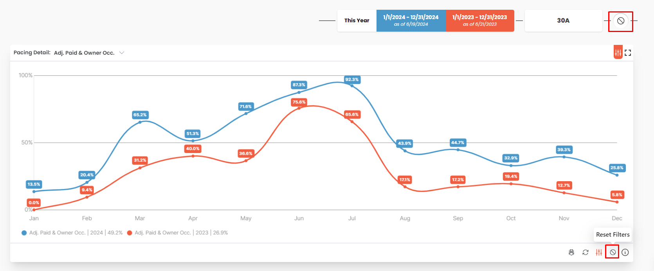

- Collapse and re-order sections within your dashboard
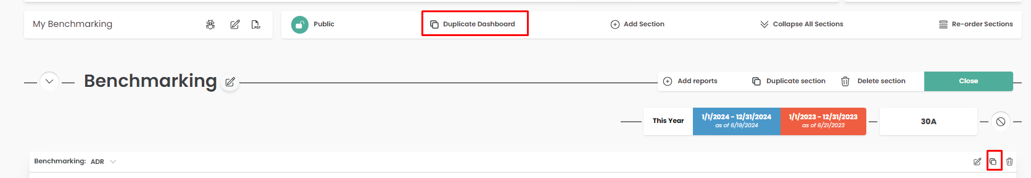

- Resize or move reports
- To move your report, Click and Drag
- To resize it, click on the bottom right corner of your report
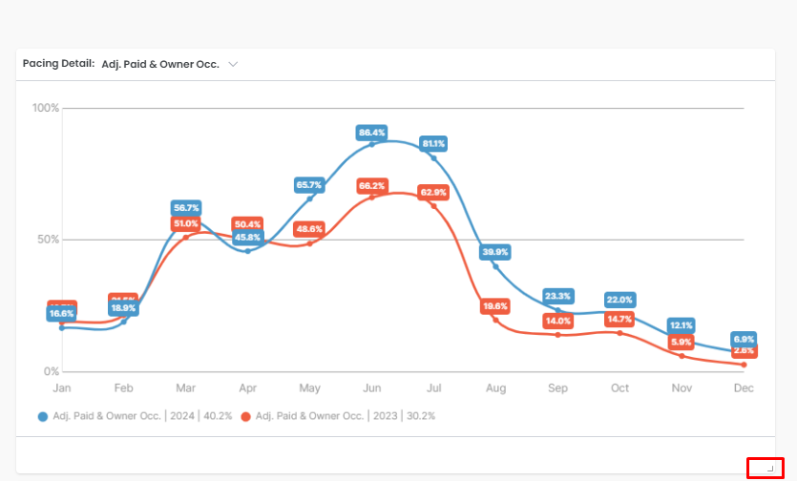
- Want a better view of the report? Detail View it
