Creating an Owner Dashboard
Owner Report- Advance

Purpose: Inform your owner about market conditions, consumer behavior and how can this be affecting their unit’s performance
Tip 1: For this dashboard we are going to add three additional different sections
Tip 2: For this dashboard we are going to duplicate the “Owner Report- Basic” dashboard and rename it

- Let’s Begin…
- Go to the “Owner Report- Basic” dashboard and duplicate it

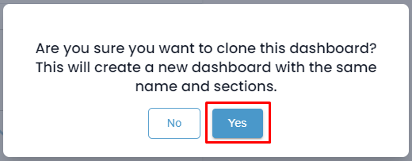

- Rename the Dashboard as “Owner Report- Advance”

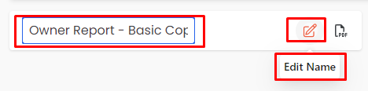

- Next, let’s create your next section, titled " Market Performance." (Remember: The second section is a market - high-level comparison involves benchmarking the unit's performance against the broader market)

- We have two options

  - Duplicate your section to retain the same filters as the first section:

    - After Duplicating your section, delete all reports
    - Rename the section
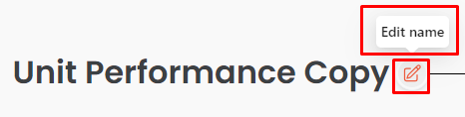
    - Add Reports

    - Add the following reports
      - Market Scorecard
      - Market Benchmarking

    - Select preferred KPI at report level (Suggestions Adj. RevPAR, APO & ADR)

  - Create a new section

- After creating adding this section a report catalog will appear
- From this catalog, browse and add the following reports to add:
  - Market Scorecard
  - Market Benchmarking

    - Once you've added your preferred reports to this section, here are a few options you can explore, depending on the data you'd like to showcase
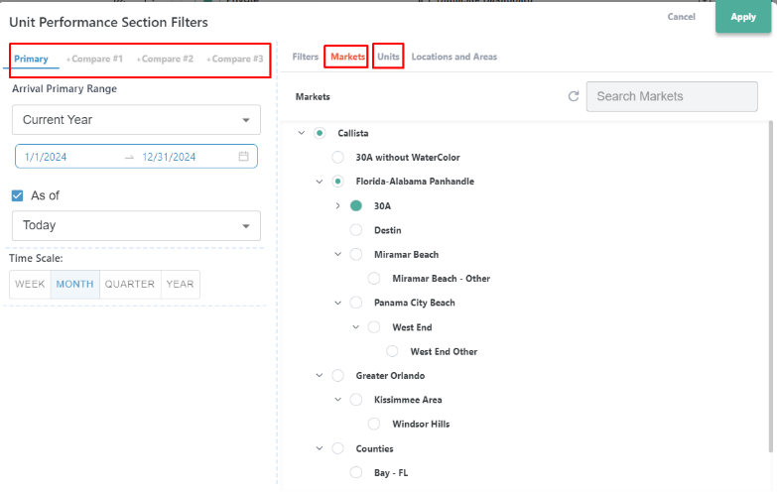
    - Adjust your filters by clicking on the date filters:
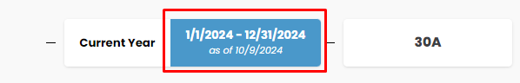

  - When your filters expand you can do the following:
  - Select your primary date and comparison dates
  - Choose the market the unit belongs to
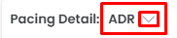
  - Select your preferred unit
  - Select preferred KPI at report level
(Suggestions: UNIT Revenue, Adj. RevPAR, APO,
ADR, Guest, Owner & Hold Nights
  - Rename, Duplicate and Delete Reports
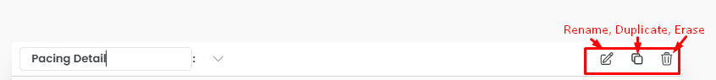

- Finally , create the other two sections " Supply & Demand “and “Consumer Behavior”
Supply & Demand involves understanding market saturation, inventory levels, and customer demand.
Consumer Behavior involves looking at booking patterns and guest preferences.

  - Duplicate your section to retain the same filters as the first section:
    - After Duplicating your section, delete all reports
    - Rename the section
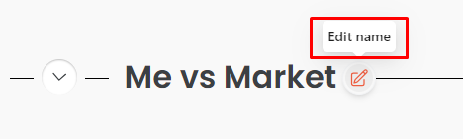

    - Change KPI at report level (Suggestions for Supply & Demand section: Nights Available, Guest Nights, Owner+ Hold Nights Adj. RevPAR, APO & ADR)
    - Change KPI at report level (Suggestions for Consumer Behavior Section: Average Booking Window & Average Length of Stay)

- Last Few Tips

- Made a mistake? Clear your filters
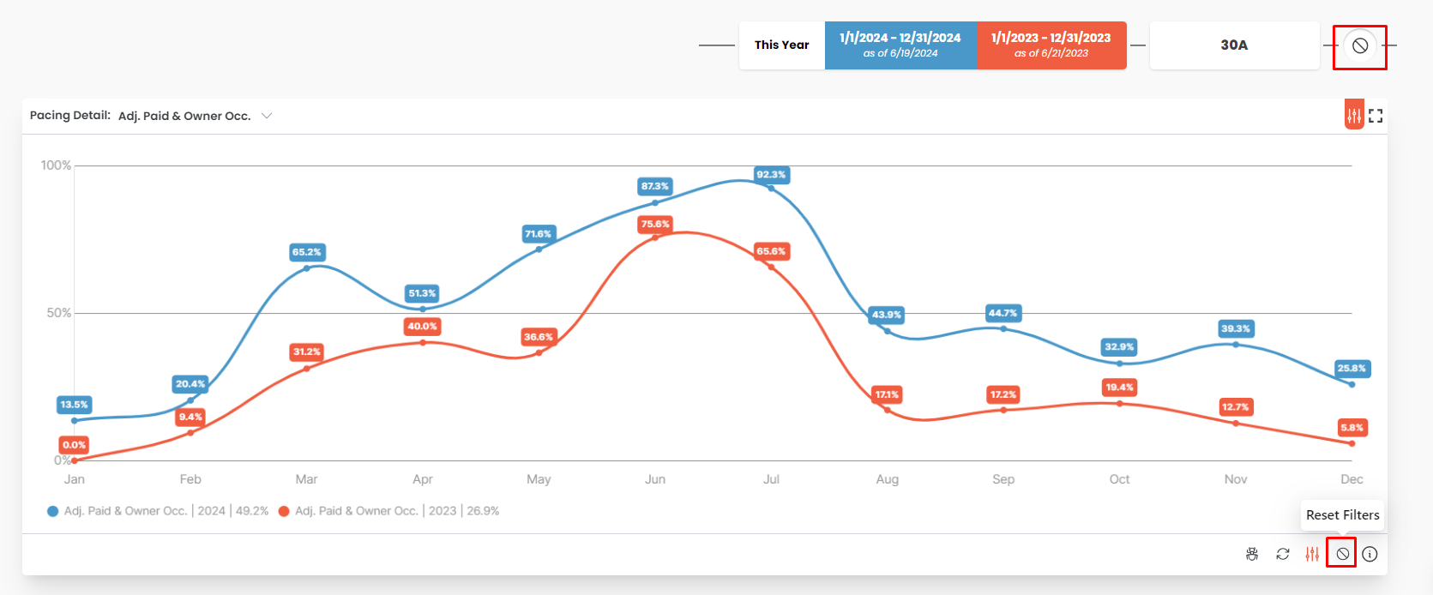

- Collapse and re-order sections within your dashboard
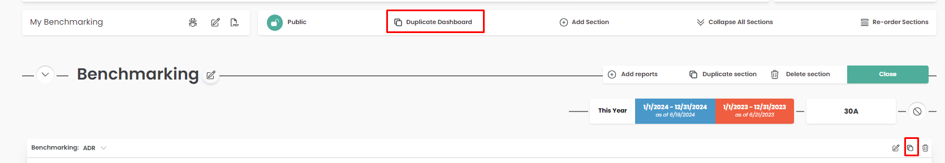

- Resize or move reports
- To move your report, Click and Drag
- To resize it, click on the bottom right corner of your report
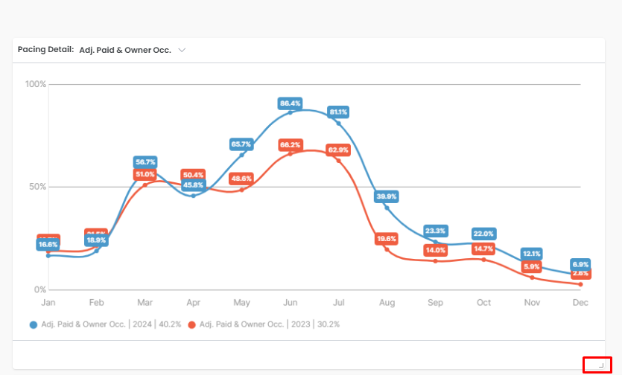
- Want a better view of the report? Detail View it
