**Creating an Owner Dashboard**

***Owner Report- Advance***

Purpose: Inform your owner about market conditions, consumer behavior and how can this be affecting their unit’s performance

Tip 1: For this dashboard we are going to add three additional different sections

Tip 2: For this dashboard we are going to duplicate the “Owner Report- Basic” dashboard and rename it

1. **Let’s Begin…**

* Go to the “Owner Report- Basic” dashboard and duplicate it



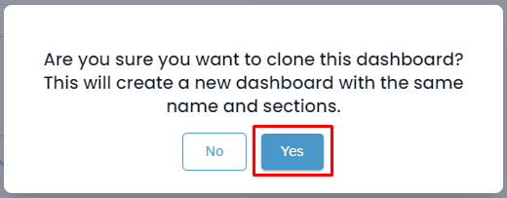

* Rename the Dashboard as “Owner Report- Advance”

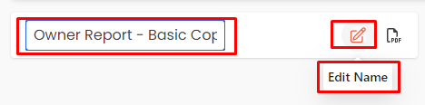

1. **Next, let’s create your next section, titled " Market Performance."** *(Remember: The second section is a market - high-level comparison involves benchmarking the unit's performance against the broader market)*

* We have two options
  + Duplicate your section to retain the same filters as the first section:



* + - After Duplicating your section, delete all reports
    - Rename the section

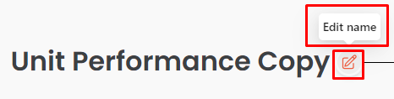

* + - Add Reports



* + - Add the following reports
      * Market Scorecard
      * Market Benchmarking
    - Select preferred KPI at report level (Suggestions Adj. RevPAR, APO & ADR)
  + Create a new section



* After creating adding this section a report catalog will appear
* From this catalog, browse and add the following reports to add:
  + Market Scorecard
  + Market Benchmarking
    - Once you've added your preferred reports to this section, here are a few options you can explore, depending on the data you'd like to showcase
    - 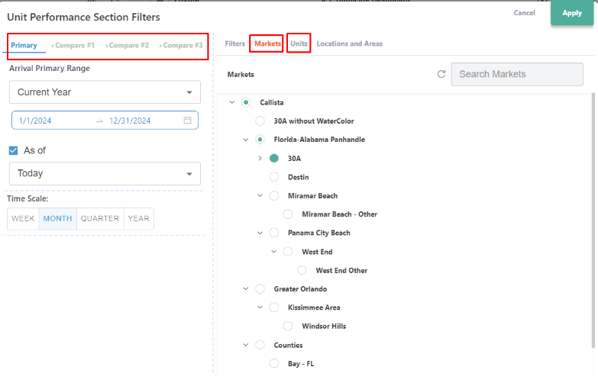Adjust your filters by clicking on the date filters:

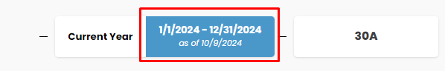

* + When your filters expand you can do the following:
  + Select your primary date and comparison dates
  + Choose the market the unit belongs to
  + Select your preferred unit
  + Select preferred KPI at report level

(Suggestions: UNIT Revenue, Adj. RevPAR, APO,

ADR, Guest, Owner & Hold Nights

* + Rename, Duplicate and Delete Reports

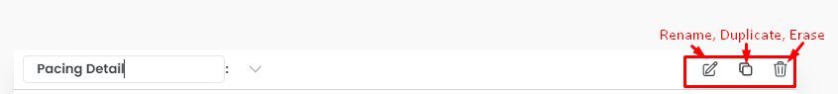

1. **Finally , create the other two sections " Supply & Demand “and “Consumer Behavior”**

*Supply & Demand involves understanding market saturation, inventory levels, and customer demand.*

*Consumer Behavior* *involves looking at booking patterns and guest preferences.*

* + Duplicate your section to retain the same filters as the first section:



* + - After Duplicating your section, delete all reports
    - Rename the section

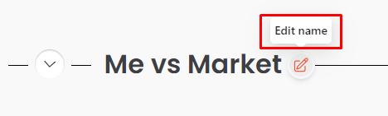

* + - Change KPI at report level (Suggestions for Supply & Demand section: Nights Available, Guest Nights, Owner+ Hold Nights Adj. RevPAR, APO & ADR)
    - Change KPI at report level (Suggestions for Consumer Behavior Section: Average Booking Window & Average Length of Stay)

1. **Last Few Tips**

* Made a mistake? Clear your filters

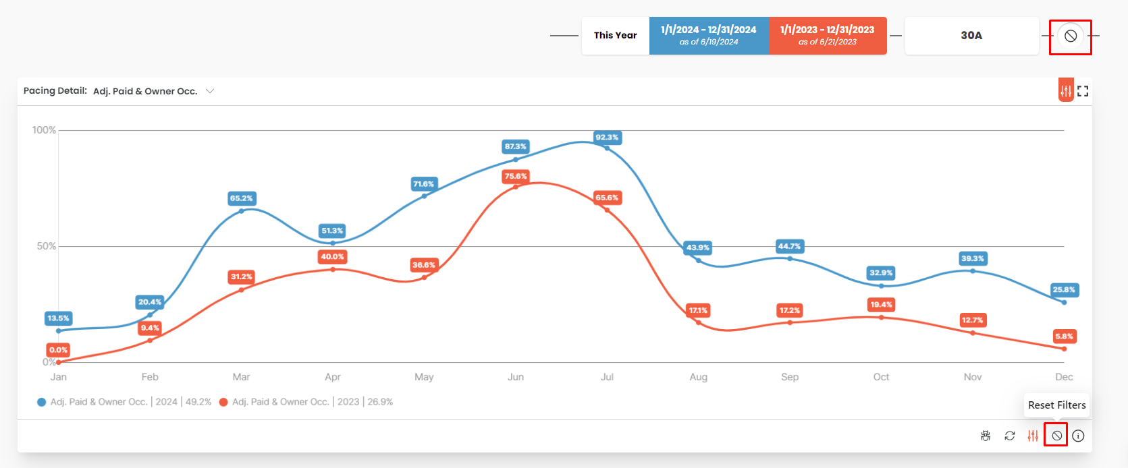

* Collapse and re-order sections within your dashboard



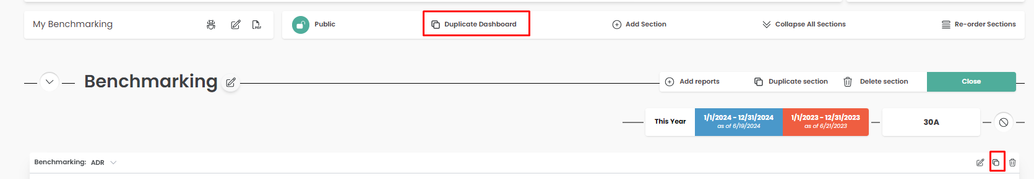

* Resize or move reports
* To move your report, Click and Drag
* To resize it, click on the bottom right corner of your report

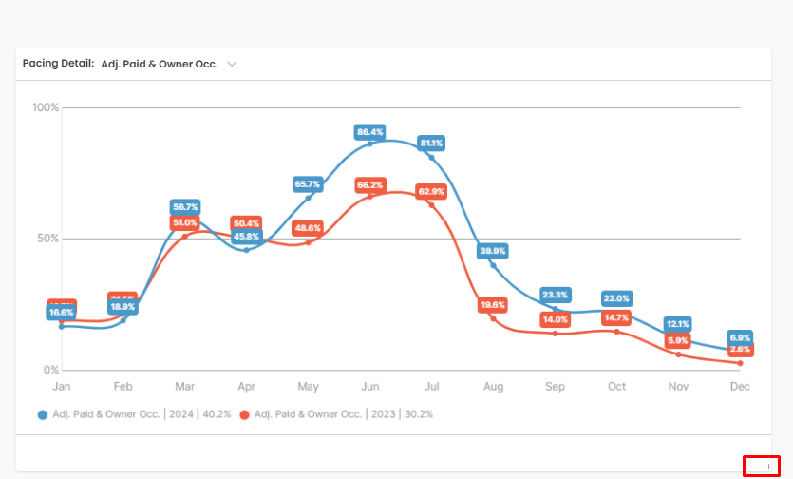

* Want a better view of the report? Detail View it

